Automatic trading robot DarkSlide
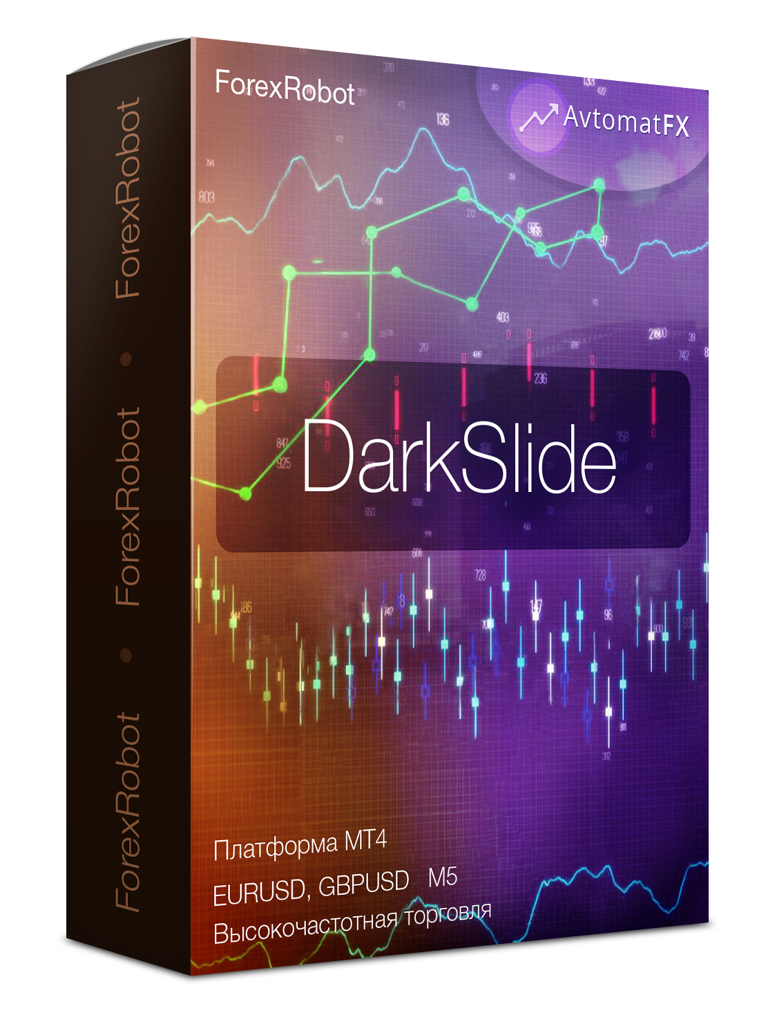

Terminal: MT4
Pair: EURUSD, GBPUSD, USDJPY, EURJPY
Timeframe: M5
Type: short-term, scalper.
Average number of deals per week: 60
Deposit: from $ 20

Algorithm:
The adviser works on the micro-level release. Levels are determined by a graphical smart algorithm. It is a scalper with a short take and a stop. It has many additional filters that are optimized at your discretion. Works on a variety of currency pairs. Is dependent on the broker. First of all, you need to consider ecn accounts with reliable brokers.

Settings:
Сomment of SET | Comment on the setting.
Magic | Magic orders on this currency pair.
Moneymanagement | Lot calculation block.
Progressive lot | If true, then a progressive lot will be used / if false - a fixed lot will be used.
Lot for 1000 deposits | The setting is used if the value is “true - progressing the lot”.  Lot will be taken for every 1000 deposit.  (for example, the setting is 0.56, and the deposit is $ 350.  Lot orders = 350/1000 * 0.56 = 0.196. The order will open with a lot of 0.20.)
Fixed lot | The setting is used if it is set to "false - progressive lot".  The order will be opened with the lot specified in this setting.
Opening an order | Settings block for opening orders.
Entry Period | The parameter that affects the sensitivity of the algorithm to the screening of signals.  The larger it is, the more signals will be eliminated.
TakeProfit (if 0 - no TP) | Take profit If the setting is zero, there will be no take profit.
StopLoss | Stop Loss.
Escort of order | Order tracking block.
Use the dynamics of spread | Use the dynamics of changes in the spread.
Entry period | Setting affecting the definition of the entry point when using spread dynamics.
Flow correction | Spread flow correction factor using spread dynamics.
Entry period for the statistical method | A setting that affects the definition of an entry point using a static method.
Security | Advanced settings block
Maximum spread | Maximum spread at which orders will be torn off.  Note: open orders will be accompanied regardless of the size of the spread.
The expiration of the pending order | Expiration date of pending orders.

